Math 7: Proportions (Chapter 5)

Targets & Problems | Answer | Expert Initials
I can compute the unit rate.  - 72 ounces for 12 servings  2. One lap around a dirt track is $\frac{1}{3}$ mile. It takes Bryce $\frac{1}{9}$ hour to ride one lap. What is Bryce’s unit rate, in miles per hour, around the track? | 1.
 | 2.
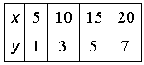  I can determine if there is a proportional relationship.  - $\frac{56}{20}, \frac{24}{10}$ 2. | 1.
 | 2.
I can solve ratio & proportion problems.  - To make 5 dinner rolls, $\frac{1}{3}$ cup of flour is used.  - How much flour is needed to make one dinner roll?  - How many cups of flour are needed to make 3 dozen dinner rolls?  - How many rolls can you make with $5\frac{2}{3}$cups of flour?  - You can buy 5 stickers for $3. What is the cost (c) if you buy 12 stickers?  - In an animal shelter, the ratio of dogs to cats is 5 to 3. There are 25 dogs. Find the number of cats. | 1a.  1b.  1c.
 | 2.
 | 3.
I can identify a direct variation. If it is a direct variation, identify the constant of proportionality and be able to write a direct variation equation.  Tell if the following show a direct variation. If so, what is the constant of proportionality?  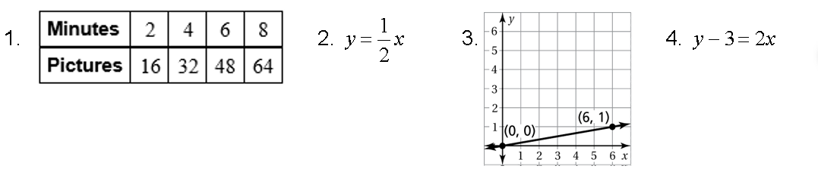 | 1.
 | 2.
 | 3.
 | 4.
Targets & Problems | Answer | Expert Initials
I can identify if a graph is proportional or not. I can explain what a point on the graph means in the context of the graph.  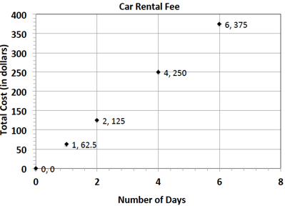  1. Does the graph show a proportional relationship? Why or why not?  2. What does the point (4, 250) represent in the context of this graph?  3. What would be the cost of renting a car for 6 days be?  4. Can you determine the unit rate from this graph? Explain. | 1.  See left
2.
See left
 | 3.
4.
See left.
I can make sense of problems & persevere in solving them. Communicate clearly & precisely.
- Jackie is making a snack mix for a party. She is using cashews and peanuts. The table below shows the relationship of the number of packages of cashews she needs to the number of cans of peanuts she needs to make the mix.
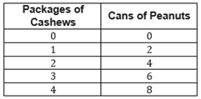
  - Write an equation to represent this relationship.
  - Describe the ordered pair (12, 24) in the context of the problem.
  - Graph the data.
I can make sense of problems & persevere in solving them. Communicate clearly & precisely.
- Championship t-shirts sell for $22 each.
  - What point(s) must be on the graph for the quantities to be proportional to each other?
  - What does the ordered pair (5, 110) represent in the context of this problem?
  - How many t-shirts were sold if you spent a total of $88?
- You earn $102 for doing 12 hours of yard work. Your friend earns $120 working at a store for 15 hours.
  - Who has a greater hourly rate of pay? How do you know?
  - What would you earn if you did 15 hours of yard work and were paid at your same hourly rate?

