Name Date

Study Guide

Chapter

8

Write and solve an equation to find the missing dimension of   
the circle.

1.  2. 

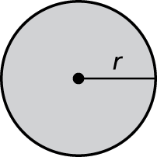 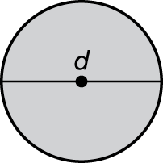

Find the circumference and area of the circle. Use 3.14 or 

3. 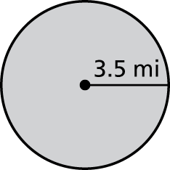 4. 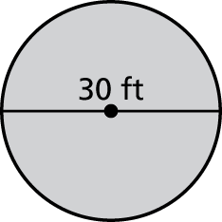

Find the perimeter and area of the semicircle.

5. 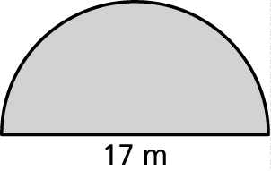 6. 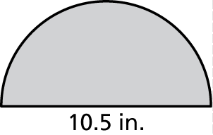

7. Explain how you could estimate the diameter of a tree by measuring   
the distance around the trunk of the tree.

Name Date

Study Guide **(continued)**

Chapter

8

Find the area of the figure.

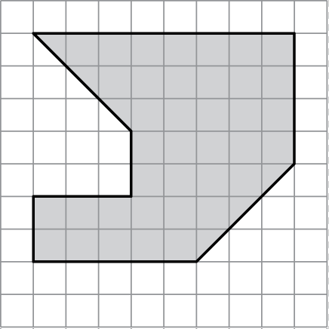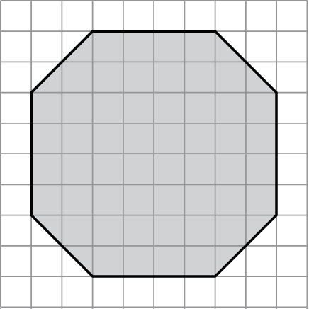 8. 9.

Find the perimeter and area of the figure.

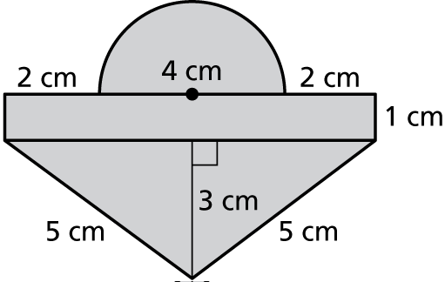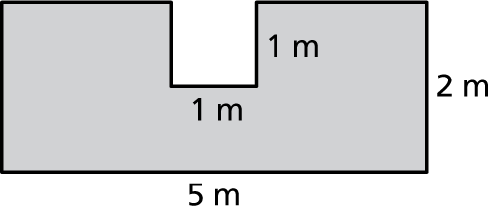 10. 11.

12. An office manager needs to decide between two tables for the conference room. One is rectangular, 5 feet wide by 10 feet long.   
The other is a circle with an 8-foot diameter.

a. Find the perimeter or circumference of each table.

b. Find the area of each table.

c. Which table can seat more people? Explain.