Name Date

Chapter 4 Study Guide

Find the area of the parallelogram, triangle, or trapezoid.

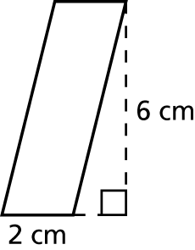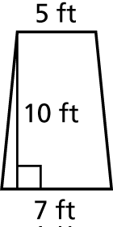 1. 2.

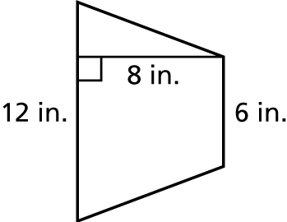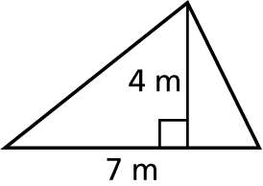 3. 4.

Find the area of the figure.

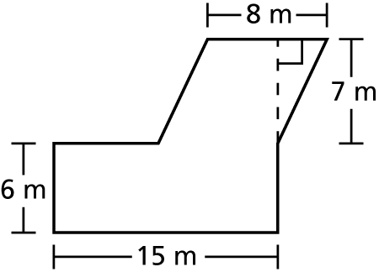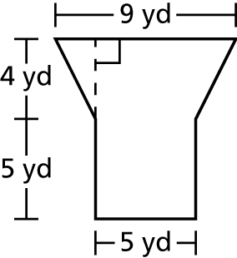 5. 6.

9. The vertices of a rectangle are *H*(1, 2), *I*(7, 2), *J*(7, 4), and *K*(1, 4).   
Find the perimeter and area of the rectangle.

11. The vertices of a polygon are *P*(1, 1), *Q*(2, 5), *R*(4, 5), *S*(7, 1).

a. What is the shape of the polygon?

b. What is the area of the polygon?

Name Date

Test B **(continued)**

Chapter

4

Find the area of the shaded region.

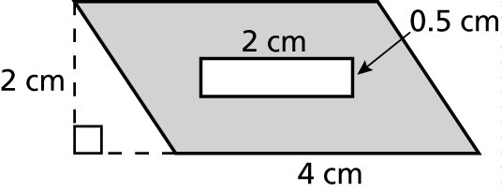 12. 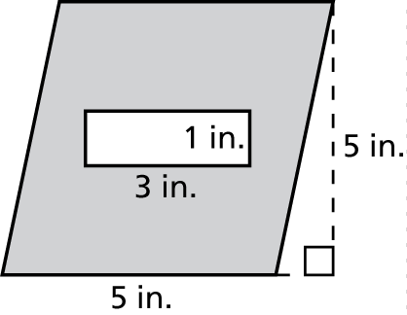 13.

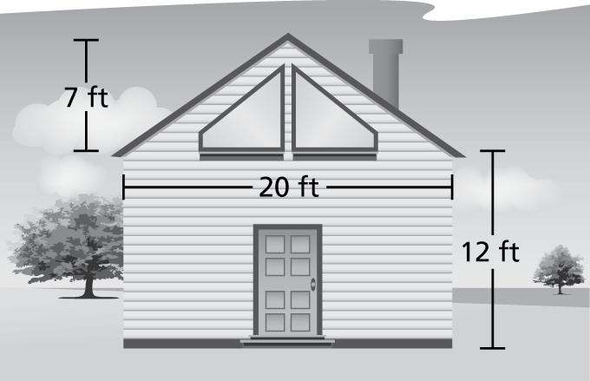 16. The side of a house is shown   
on the right.

a. Find the total area of the   
side of the house.

b. The two trapezoidal   
windows each measure   
5 feet across, have outside  
edge lengths of 1 foot and   
inside edge lengths of 5 feet.   
What is the area of one window?

c. The rectangular door is 4 feet wide and 7 feet tall. What is the area of the door?

d. How many square feet of paint will it take to paint the side of the house?