Name Date

Math 6 - Chapter 2 Study Guide

Multiply. Write the answer in simplest form.

1.  2. 

3. 

Divide. Write the answer in simplest form.

4. 

5.  6. 

**Evaluate the expression. Write the answer in simplest form.**

7. 

Add or subtract.

8.  9. 

Multiply.

10.  11. 

Divide.

12.  13. 

Evaluate the expression.

14.  15. 

16. A professor wants to divide the remaining of the semester evenly   
into six different units.

a. What fraction of the semester should be spent on each unit?

b. The professor drops one unit. What fraction of the semester should be spent on each unit?

17. Find the area of the credit card.

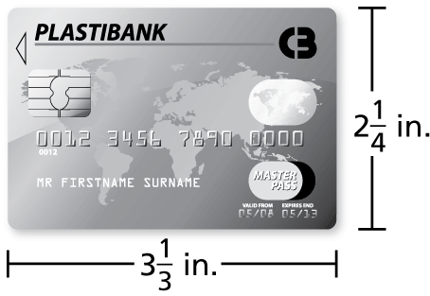

18. A recipe makes cups. The serving size is cup. How many servings does the recipe make?

19. A market sells a six-pound bag of potatoes for $6.27 and a 7.5-pound bag of potatoes for $7.65. Which bag of potatoes is a better buy?