Name Date

Chapter 10 Study Guide

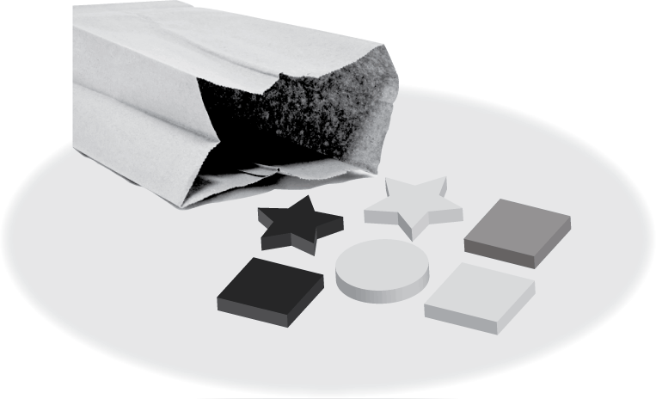You randomly choose one shape   
from the bag. (a) Find the number   
of ways the event can occur.   
(b) Find the favorable outcomes   
of the event.

1. Choosing a square

2. Choosing a circle

3. *Not* choosing a star

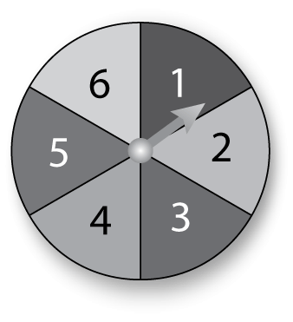

You spin the spinner once. Find the theoretical probability of the event.

4. Spinning a 5

5. Spinning an odd number

You throw two sticks 15 times and record the results. Use the table to find the experimental probability of the event.

|  |  |
| --- | --- |
| Outcome | Frequency |
| 2 blue | 4 |
| 2 pink | 3 |
| 1 blue, 1 pink | 8 |

6. Tossing 2 blue

7. Tossing 1 blue and 1 pink

8. *Not* tossing all blue

Use the Fundamental Counting Principle to find the total number of possible outcomes.

9. 10.

|  |  |
| --- | --- |
| Video Game | |
| Level | Beginner, Intermediate, Advanced |
| Character | Fish, Bird, Frog, Monkey, Horse |

|  |  |
| --- | --- |
| Vacation | |
| Location | Amusement Park, Historical Landmark, Beach, Mountains |
| Transportation | Plane, Car, Train |

A game has a deck of cards with 10 red cards, 4 blue cards, and   
2 yellow cards. You randomly choose two cards. Find the probability   
of choosing the given cards.

11. two red cards 12. a blue card and a yellow card



You spin the spinner twice. Find the probability of the event.

13. Spinning a 3 then a 4

14. Spinning a 2 then a number greater than 2

15. Your drawer contains 6 black socks and 8 white socks. You randomly choose two socks. What is the probability that both socks are black?

16. Which sample is better for making a prediction? Explain.

Sample A: A random sample of 5 gallons of water from one location in a river

Sample B: A random sample of 5 gallons of water from five different locations in a river

17. The double box-and-whisker plot shows the numbers of correct answers on a test for each student in Room 212 and Room 214.

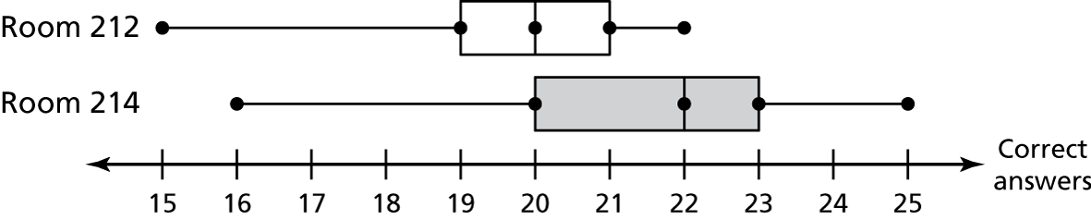

a. Compare the populations using measures of center and variation.

b. Express the difference in the measures of center as a multiple of each measure of variation.