Math 7: Expressions & Equations Unit Plan (Chapter 3)

Targets & Problems | Answer | Expert Initials
I can identify terms and like terms.  - How many terms are in the following expression?  $3x^{2}+3+7x+14-x^{2}+3-5x$  - Use highlighters or colored pencils to identify the like terms in the following equations.  - $3x-4+7x+3-2x^{2 }$ b. $7-8b+24-17b-3$ | 1.
2.
See left
I can combine like terms to simplify an expression.  Simplify the following expressions.  - $3n+7-n-3$ 2. $3(2+d)=15$  3. $6.4r-7-2.9r$ 4. $\frac{3}{5}x+19-\frac{3}{20}x-7$ | 1.
 | 2.
 | 3.
 | 4.
I can add and subtract linear expressions.  Find the sum or difference.  - $(c-4)+(3c+9)$ 2. $2(5z+4)+(3z-6)$  3. $(2r-13)-(-6r+4)$ 3. $(4x+3)-(2x-1)$ | 1.
 | 2.
 | 3.
 | 4.
Targets & Problems | Answer | Expert Initials
I can factor an expression.  Factor using the Greatest Common Factor.  - $15w+64$ 2. $36a + 16b$  Factor out the coefficient of the variable.  3. $\frac{3}{8}d+\frac{3}{4}$ 4. 6x - 18 | 1.
 | 2.
 | 3.
 | 4.
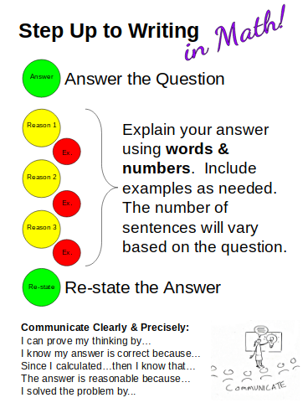  I can write & solve a 1-step equation.  Solve.  $p-3=-4$ $n+\frac{3}{4}=\frac{1}{4}$ $\frac{x}{3}= -8$ $-4x=-8$  Write an equation then solve.  A company makes a profit of $1.38 million. This is 2.54 million more than last year. What was the profit last year? | 1.
 | 2.
 | 3.
 | 4.
5.
See left
I can write and solve a 2-step equation.  Solve.  $2v+7=3$ $-6t-7=17$ $\frac{3}{5}g-\frac{1}{3}= -\frac{10}{3}$ $4+2.2h= -3.7$  Write an equation and solve.  It costs $2.50 to rent bowling shoes. Each game costs $2.25. You have $9.25. How many games can you bowl? | 1.
 | 2.
 | 3.
 | 4.
5.
See left
I can use complete sentences and appropriate vocabulary to explain the answer to a mathematical question.

- Gabby & Lauren have $12 between them. They need to take a taxi to meet their other friend who is 4 miles away. A taxi service charges an initial fee of $3.00 plus $1.80 per mile. Lauren says they can afford the taxi. Is this correct? Support your answer using words and numbers. Show your work in the space to the right.
_____________________________________________________
_____________________________________________________
_____________________________________________________
_____________________________________________________
___________________________________________________________________________
___________________________________________________________________________
- Ryan and Claire are solving the equation $-3x + 7= -14$. Ryan says the answer is $x=7$. Claire says the answer is $x= -7.$ Who do you agree with and why? Explain using words and
numbers. Show your work in the space to the right.
_____________________________________________________
_____________________________________________________
_____________________________________________________
_____________________________________________________
___________________________________________________________________________
___________________________________________________________________________

